The Islamia University of Bahawalpur
Department of Computer Science



SOFTWARE DESIGN DOCUMENT
(SDD DOCUMENT)
for

Sounds. (E-commerce store)

Version 1.0

By
Ayesha Akram

23239555009

Session fall 2023 – 2025

Supervisor
Sir Mirza Nasir

Table of Contents
1. Introduction 1
2. Design methodology and software process model 2
3. System overview 3
4. Design models 7
5. Data design 11
6. Algorithm & Implementation 13
7. Software requirements traceability matrix 13
8. Human interface design 14
9. Appendix I 24

Revision History

Name | Date | Reason for changes | Version

Application Evaluation History

Comments (by committee)  *include the ones given at scope time both in doc and presentation | Action Taken

Supervised by

Sir Mirza Nasir

Signature:

Introduction

1.1 Purpose
“Sounds.” is an E-commerce store. It is a web application which sell audio products. It is pronounced as ‘Sounds Dot’. “Sounds.” will be targeting consumers that need audio products e.g. Earbuds, hand free, speakers and woofers that matches their lifestyle.

1.2 Scope
The functional scope of the system has the following main features:
- To record details of Customer
- To record information of New Registered Customer
- To record the location of delivery products
- To record information of Products
- To Update, delete and Add new Products
- To record information of Delivery Service
- To record information of Custom Products
- To record information of Online Payment
- To generate reports

1.3 Overview

The System has various modules as:
- Security Management
- Product Management
- Order Management
- Payment
- Claiming
- Custom Product
- Rating
- Wish List
- Notifications
- System Suggestions
- Return & Exchange Policy
- Report Generation

- Product Management: will help to manage the add product, update product, search product, delete product, product categories. Only Admin can manage the products.
- Security Management: will provide the access to the system according to the privileges of the user. This will used to authenticate the user accessing the system. And also providing the facility to change the password and to recover password.
- Order management: will help to manage order details, track order, place order and order status.
- Payment Module: will help in different payment methods that will be provided to customer like Easy Paisa/Visa Card or Cash on Delivery.
- Claiming Module: will help to manage different types of claims like product claims and also update those claims as soon as possible.
- Custom Product: is the key module of application that will provide customers an astonishing experience of designing their own product.
- Rating Module: will manage product rating that has been given by customers depending upon the quality of product and other services which include Reviews, Commenting and FAQ. User will also give rating about employee who delivered order.
- Wish List Module: will manage the products that has been selected by customers as a favorite product which they will buy later.
- Notifications: will manage all the notification area which will be either order notifications, delivery notifications, new customer login notifications or payment notifications.
- System Suggestions: will manage all the searches of customer and give them new product suggestions based on their previous searched item according to their interest.
- Return & Exchange: will manage all the items that got complain from the customers and based on those complains first company check the defaults then apply return or exchange policy like Cash back, Product Exchange, Product Return.
- Report Generation: will manage all orders received from customers, delivered orders, employee reports and monthly sales report.
Reference

Design methodology and software process model
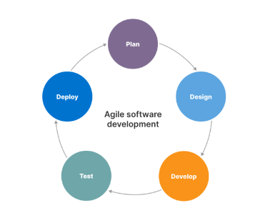
Figure 2.1: Agile Process model
The Agile methodology is one of such developments, which is specially created for e-commerce websites, apps and software. It also works for individual and group interactions through various tools, software using relevant documentation, contract negotiation through customer collaboration and response.
Being a response to the ever-changing competition and customer trends using the latest technology, the Agile methodology works with a blend of business and technical SMEs in e-commerce to ensure a smooth and effective functionality and an overall great performance.
It has been widely said that agile methodology for e-commerce is a perfect match, and there are many examples to prove that with the following benefits –
- Higher speed
- Observing market interest
- Better product quality
- Flexibility
- Less risks
- Regular and rigorous testing
- Happier customers
That’s why we are using agile methodology in our website.

System overview
“Sounds.” is an online on-demand service from which users can buy things on-demand and will get delivery in 1-2 days. This service is very useful for users which have busy schedules and they don’t have much time for shopping and sales of contractors will also increase. This Service will be available 24 hours.
- Systems Perspective: This Joy Garments is a completely new system for the users of Online Shopping. It has the database of transactions, customer’s details, Account’s details, online ordering etc.
- Assumptions and dependencies: Our business will offer 24-hour service within certain areas. The 24-hour service depends on the availability of delivery services. All the end user services dependent upon server by using Internet as a medium, but if the server is down or the Internet speed is not sufficient then users will fail to achieve these facilitating services. If any change occurs in our system then it will not much effect our documentation in order to purchase things Consumer must have Cash on Delivery/Easy Paisa/Visa card in his/her possession else consumer cannot order. Our Sounds dot application will be only available in Web Application.
- Cost and pricing: This is my Semester Project and has no Cost & Pricing.

3.1. Architectural design

ER Diagram for E-Commerce Website

Figure 3.2: ER Diagram

3.2. Process flow/Representation

Activity Diagram to represent process flow of Admin side
Figure 3.2: Activity diagram

Activity Diagram to represent process flow of User side

Figure 3.3: Activity diagram

Design models

  - Class Diagram
The purpose of this diagram is to show object within the e commerce system interact with each other in order to achieve the functionality required by the use case diagram. The purpose of the diagram is to introduce some common terms, "dictionary" for online shopping - Customer, Web User, Account, Shopping Cart, Product, Order, Payment, etc. and relationships between. It could be used as a common ground between business analysts and software developers.
The following diagram show the class diagram of online shopping store.

Figure 4.1: Class diagram

  - Sequence Diagram
Here is the sequence diagram of login screen .which will check data from database that login user is valid or not. In this the user will enter his data in required filed if data is valid and it will redirect to his related dashboard. If data is invalid and it will redirect to his login screen .if it has no account he will first register in his database.

Figure 4.2: Sequence diagram

  - Data Flow Diagram
A data flow diagram for e-commerce is used to depict the overall data flow in an E-COMMERCE WEBSITE SYSTEM. The data flow diagram for e-commerce illustrates how the project will handle the included data. The Data Flow Diagram (DFD) depicts the data flow and transformations in an e-commerce website. The input, processing, and output represent and define the overall data flow diagram for an e-commerce website. The following charts complete the E-Commerce Website Data Flow Diagram (DFD). Each of these Levels discusses its roles in emphasizing the e-commerce website's work.

DFD for Customer side

Figure 4.3: Data flow diagram for customer

DFD for Admin side

Figure 4.4: Data flow diagram for Admin

Data design
The database consists of:
- Admins: Admin information is added to database with Unique ID based on their roles.
- Users: Users information is added to database with unique email address.
- Products: All products information is added to the database with auto generated unique ID.
- Cart: The products that a user/customer wants to buy and added them to cart. Their information is also stored in database.
- Orders: Orders information is added to database with auto generated unique ID.
- Messages: Users messages information is added to the database.
- Wish list: Favorite product information is added to the database with unique ID which is auto generated.

Data Objects consists of:
- Admins: ID, Name, Password, Role
- Users: ID, UserName, Email, Password.
- Products: ID, ProductName,Details, Price, Image1, Image2, Image3.
- Cart: ID, UserID, ProductID, ProductName, ProductPrice, Quantity, Image.
- Orders: ID, UserName, UserName, ContactNO, Email, PaymentMethod, Address, Quantity, TotalPrice, PlacedOn, PaymentStatus.
- Messages: ID, UserID, UserName, Email, ContactNo, Message.
- Wish list: ID, UserID, ProductID, ProductName, Price, Image.

Database Tables:
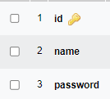  Table 5.1: Admin | 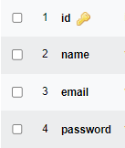  Table 5.2: User | 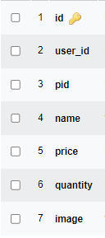  Table 5.3: Cart
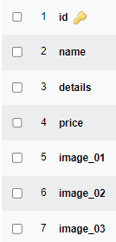  Table 5.4: Product | 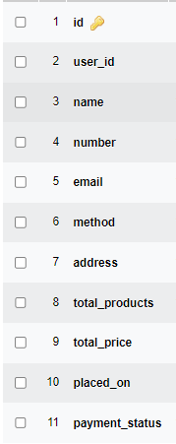  Table 5.5: Orders | 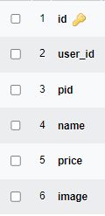  Table 5.6: Wish list
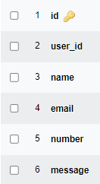
Table 5.7: Messages

Algorithm & Implementation
In this section, we take a closer look at what each component does in a more systematic way. Provide a summary of your algorithm for each function listed in procedural description language (PDL) or pseudo code.

If you gave an OO description, summarize each object member function for all the objects listed in PDL or pseudo code. Describe any local data when necessary.

Software requirements traceability matrix
In this Section we see Functional and non-functional requirements for each object. Where Functional requirements are denoted by “ F ” and non-functional requirements are denoted by “ NF ”.
Table 7.1 Requirements Traceability Matrix
Req. Number | Type | Description | Component Items
R01 | F | The application will provide the facility of registration. | Register
R02 | F | The application will provide the facility of login. | Login
R03 | F | The Application should provide the facility to view profile | Profile
R04 | F | The application should provide the facility to place order. | Order
R05 | F | The application will provide the facility to user to cancel order. | Cancel order
R06 | NF | The user’s personal information (password, email id, phone no) not access by another user. | Data constraint
R07 | NF | The Application should available all the time | System
R08 | NF | The Application has the capability of accessing and handling to over multiple users at a time. | System
R09 | NF | After entering the user name and password the user can access his profile and details of user must be secure and safe. It provides the high level security for the database of user. | View method
R10 | F | The application will allow user to add product to cart. | Add to cart
R11 | F | The user can send message to the admin. | Message

Human interface design
Described the functionality of the system from the user’s perspective. In it explaining that how the user will be able to use our system to complete all the expected features and the feedback information that will be displayed for the user.

Screen images

    - Home Page: The Home Screen will consist of screen where one can browse through the products which we have on our website.

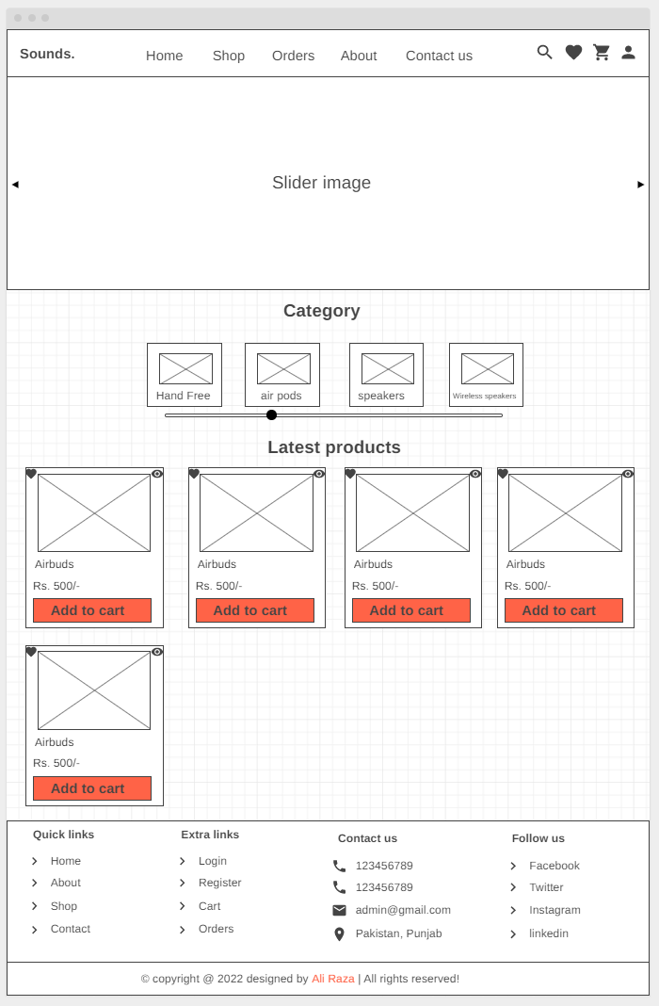
Figure 8.1.1: Home page

    - Shop Page: The Shop Screen will consist of screen were one can browse through the products which we have on our website. Registered users can order desired products from here.

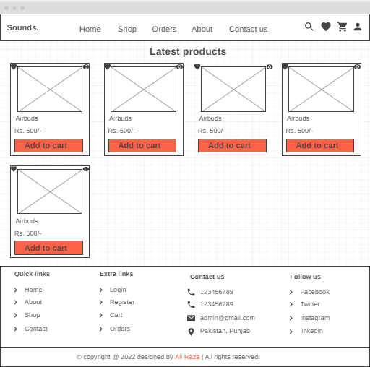
Figure 8.1.2: Shop page

    - User Login Page: The user login page is used by customers to see their carts and orders.

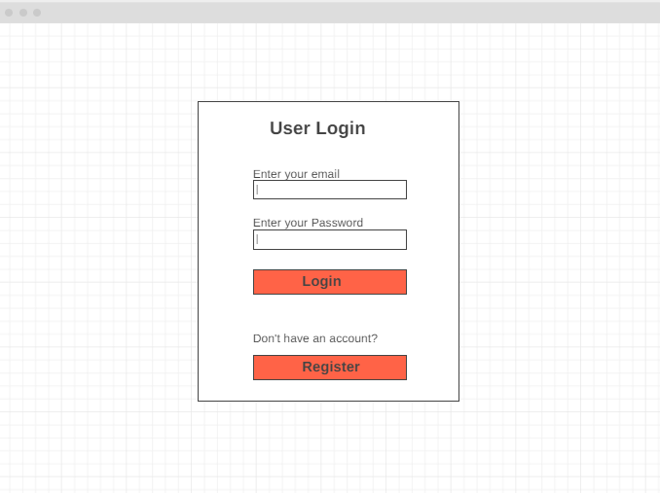
Figure 8.1.3: User Login page

    - User Registration Page: The registration page is used by new customers. They create their accounts here.

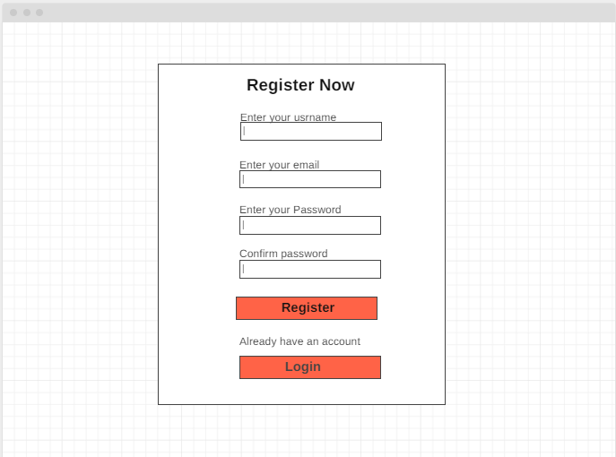
Figure 8.1.4: User Registration page

    - Shopping Cart Page: Customers add there required products into the cart.

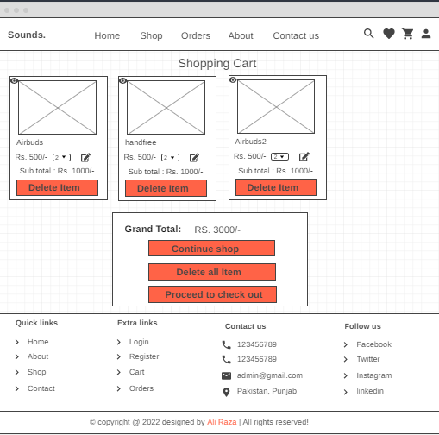
Figure 8.1.5: Shopping Cart page

    - Check out Page: Used by customers to check out for payment.

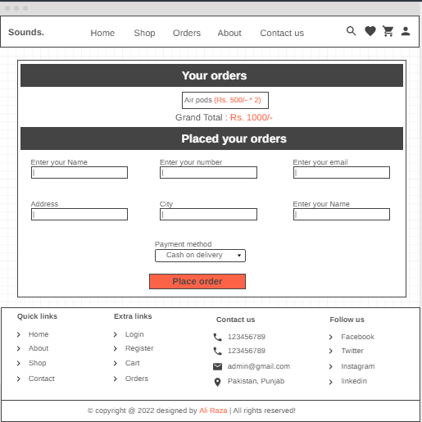
Figure 8.1.6: Check out page

    - Contact Us Page: Customers or visitors can contact us from here.

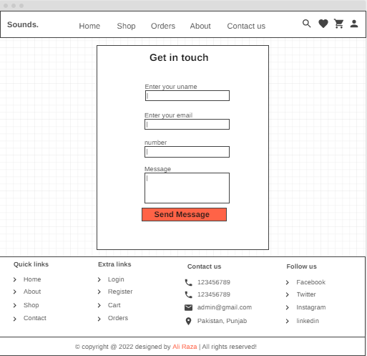
Figure 8.1.7: Contact us page

    - About us page: Customers or visitors can know about us from here.

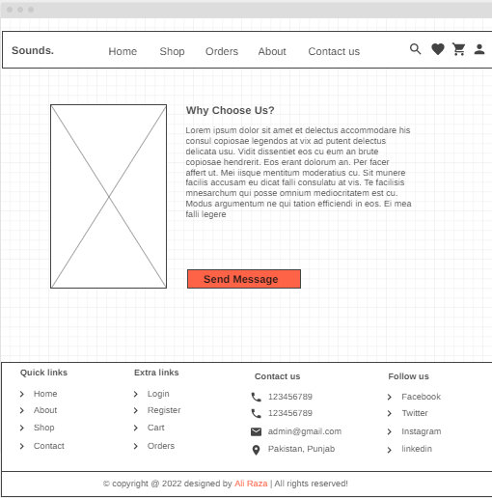
Figure 8.1.8: About Us page
    - Admin Login Page: The Admin login page is used by admins.

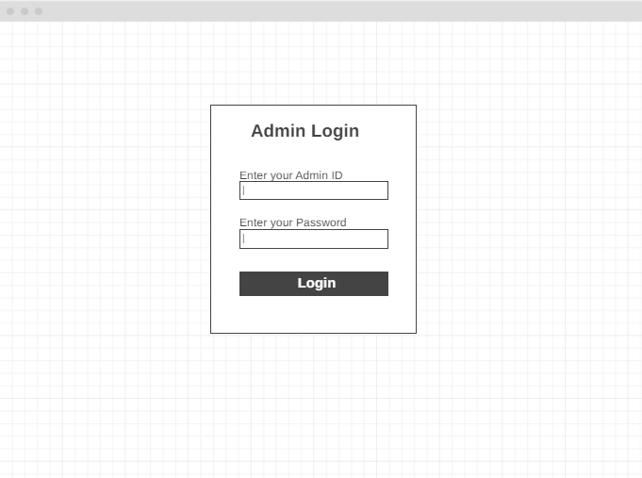
Figure 8.1.9: Admin Login page

    - Dashboard: Website Administrators can track and ship orders here.

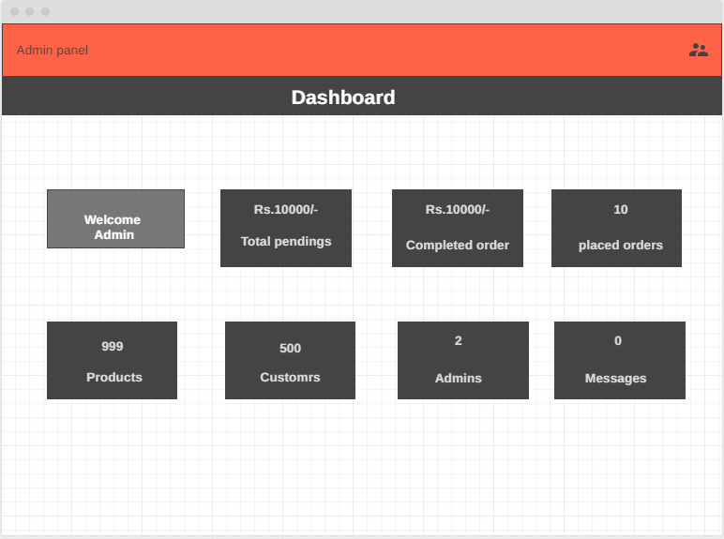
Figure 8.1.10: Dashboard

    - Total pending’s: Admin can track his pending sells here.

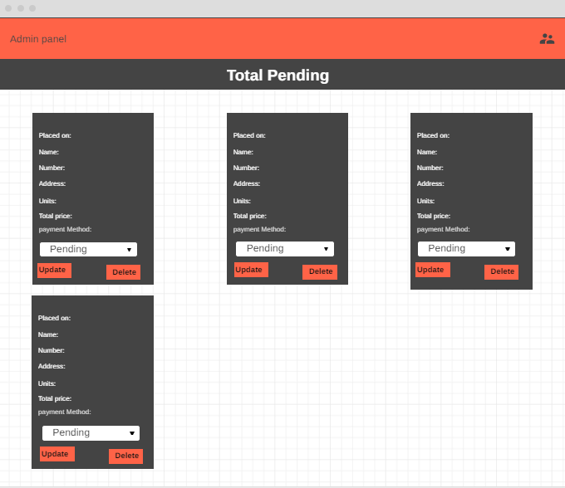
Figure 8.1.11: Total pending

    - Completed orders: Admin can track his orders here.

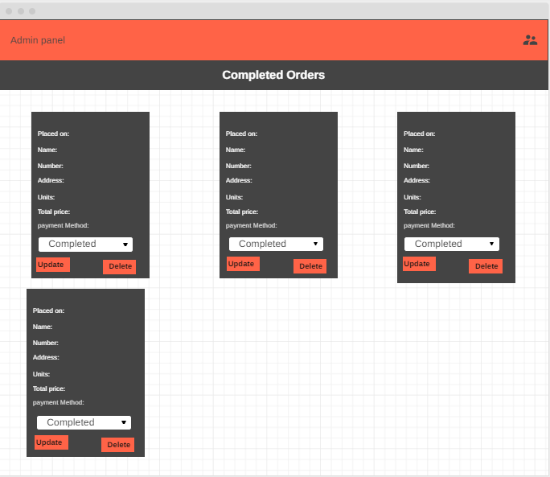
Figure 8.1.12: Completed orders

    - Placed orders: Admin can track his orders here.

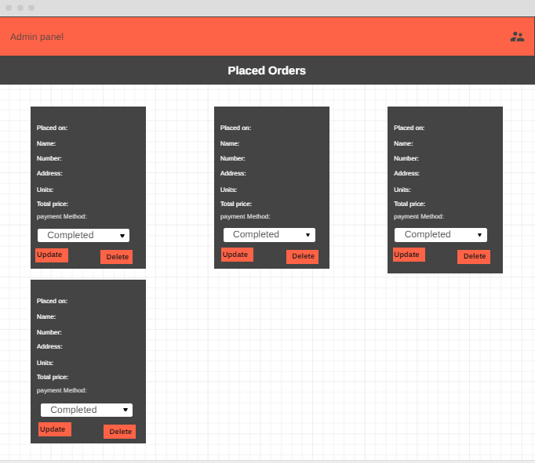
Figure 8.1.13: placed orders

    - Products Page: Admin can manage his products.

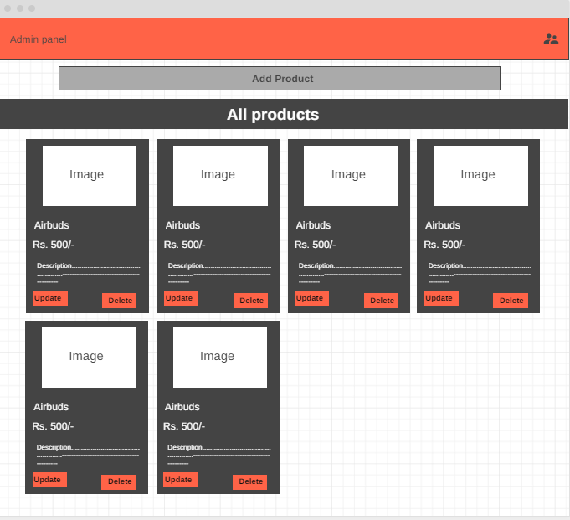
Figure 8.1.14: Products page
    - Customers Page: Admin can manage customers here.

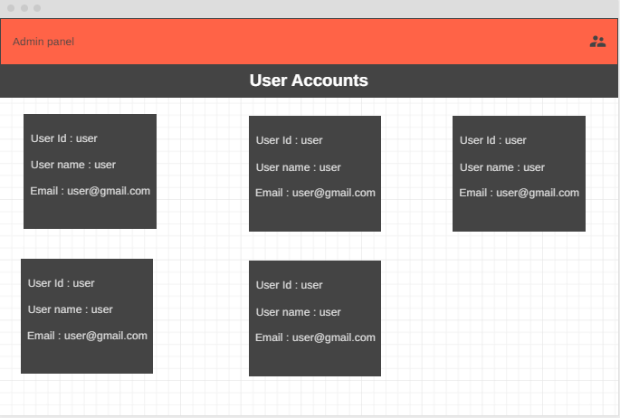
Figure 8.1.15: Customers page

    - Admin page: Admin can add or delete administrator from here.

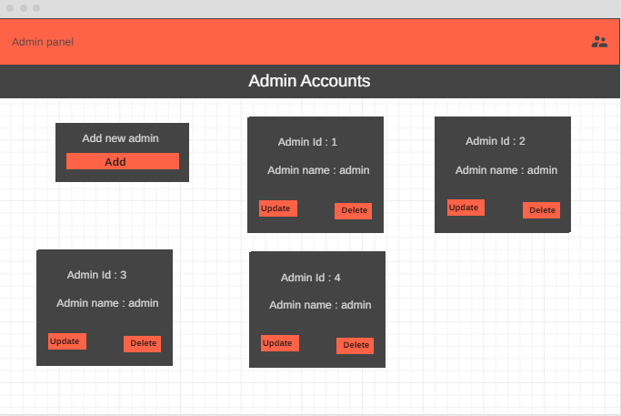
Figure 8.1.16: admin page

Screen objects and actions
Home: On the home page there are following icons:
- Header section include:
  - Profile is used to see profile by user.
  - Cart is used to see the cart.
  - Wish list is used to see the favorite products list.
  - Navigation bar to access other pages (Home, shop, about us, contact us, orders) of the websites.
  - Slider to show latest products and on sale products.
  - Search bar is used to search different products from the website.
- Category block displays products of different products.
- Footer contains quick links to navigate through the pages.
Shop: On the shop page there are following icons:
- Header section include:
  - Profile is used to see profile by user.
  - Cart is used to see the cart.
  - Wish list is used to see the favorite products list.
  - Navigation bar to access other pages (Home, shop, about us, contact us, orders) of the websites.
  - Search bar is used to search different products from the website.
- Category block displays products of different products.
- Footer contains quick links to navigate through the pages.
Login, Registration: On this page there are following objects:
- Header section
- Text boxes for input data and buttons login and register.
Shopping Cart: Shows the products that we want to buy and there total price.
- Header section
- Displays the buttons to shop more, check out, and delete items.
- Footer section
Check out page: On this page get information of the customer.
- Header section
- Fields to get data from customer and postal address.
- Place order button to place the order.
- Also display the total bill of the order.
- Billing Method
- Footer section
Contact us page: To contact with the admin of vendor.
- Header section
- Fields to get data from customer and postal address.
- Place order button to place the order.
- Also display the total bill of the order.
- Billing Method
- Footer section
About us page: To contact with the admin of vendor.
- Header section
- Displays the information about the vendor
- Footer section

Appendix I
- WWW.W3Schools.com
- http://www.google.com
- Somerville, I, Engineering A Practitioner’s Approach McGraw Hills, 2001
- Learn More | TryBooking.com
- http://.slideshre.net/FNISHA/online-ecommerce-website
- Software Engineering –A Practitioner‟s approach by Roger Pressman
- Ian Sommerville – Software Engineering 9th Edition– Chapter 6

